**Lab Report 1 - Arduino**

**Nancy Hoang (ndh9tsj) and Nicolas Meneses (nm3bkj)**

**Exercises:**

1. **Light is on for 100ms and off for 900ms**
   1. We observed that the light is flickering faster as a result. This is due to the fact that the light is on for less time.
2. **Light is on for 50 ms and off for 50 ms**
   1. We observed that the light is blinking super fast and it is pretty difficult to distinguish between it being on and off.
3. **Light is on for 10 ms and off for 10ms**
   1. We observed that the light appears to just be on the entire time and there is no flickering.

**Assignment:**

**Code:**

int redPin = 11; // output pin number to Red pin of the LED

int greenPin = 10; // output pin number to Green pin

int bluePin = 9; // output pin number to Blue pin

void setup() // this runs once, when the sketch starts

{

pinMode(redPin, OUTPUT); // sets the pin as output pin

pinMode(greenPin, OUTPUT); // sets the pin as output pin

pinMode(bluePin, OUTPUT); // sets the pin as output pin

}

void loop() // this runs over and over again forever

{

int value = 0;

for (int i = 0; i < 255; i++)

{

analogWrite(bluePin, i); // Outputs analog value i on redPin using PWM.

// value range: 0 ~ 255 (0: off, 255: fully on)

delay(10); // waits 10 ms

}

for (int i = 0; i < 255; i++)

{

analogWrite(bluePin, 255-i); // Outputs analog value i on redPin using PWM.

// value range: 0 ~ 255 (0: off, 255: fully on)

analogWrite(redPin, i);

delay(10); // waits 10 ms

}

for (int i = 0; i < 255; i++)

{

analogWrite(redPin, 255-i); // Outputs analog value i on redPin using PWM.

// value range: 0 ~ 255 (0: off, 255: fully on)

analogWrite(greenPin, i);

delay(10); // waits 10 ms

}

for (int i = 0; i < 255; i++)

{

analogWrite(greenPin, 255-i); // Outputs analog value i on redPin using PWM.

// value range: 0 ~ 255 (0: off, 255: fully on)

delay(10); // waits 10 ms

digitalWrite(greenPin, LOW);

}

}

**Setup Picture:**

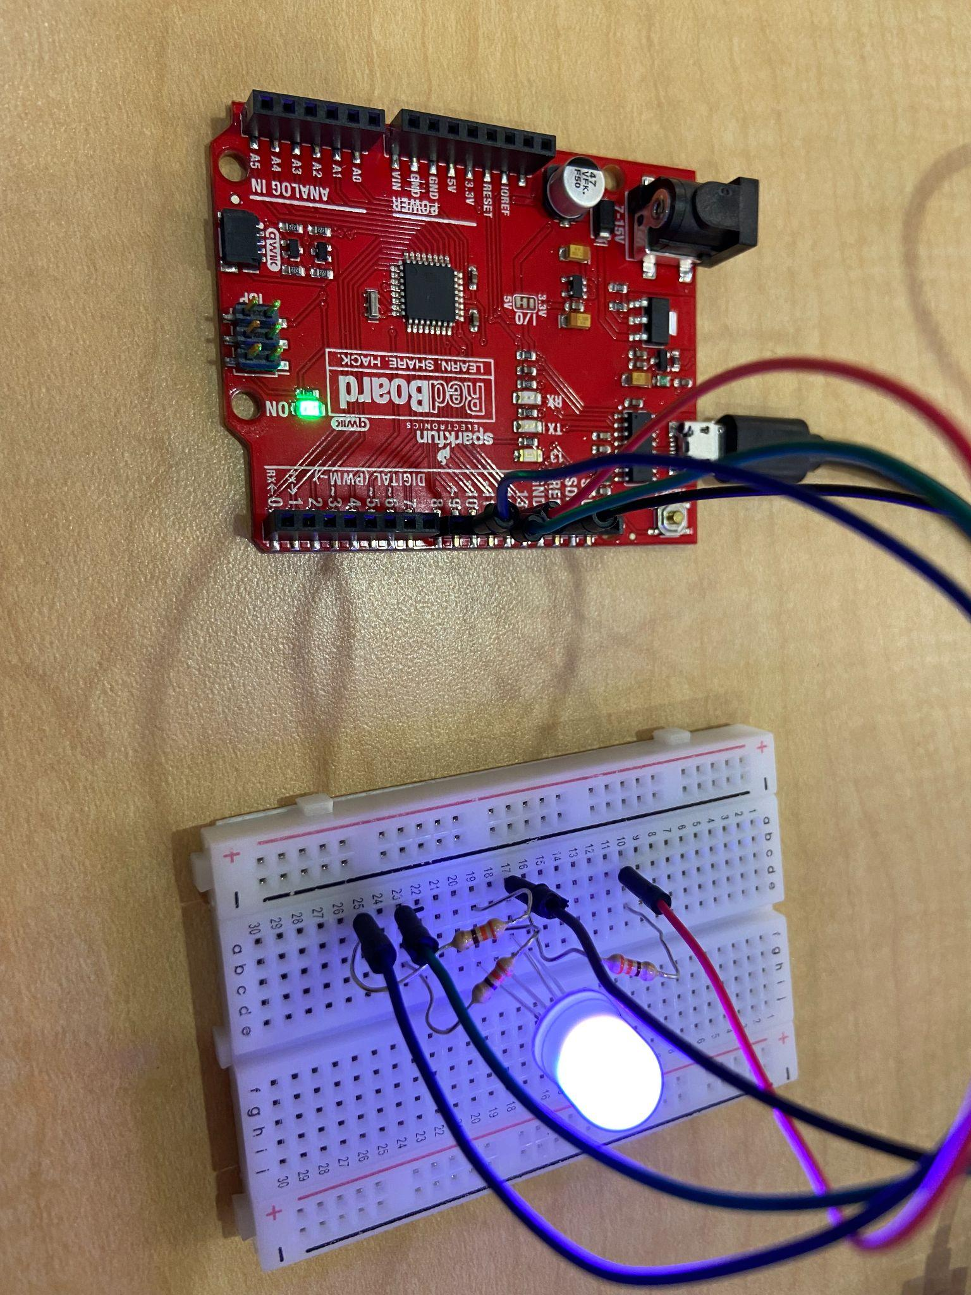

**Video Result:** in zip file